#### SAN FRANCISCO STATE UNIVERSITY

**Procedure for Tenure Track Search Travel/Other Costs**

**REVISED for 2022-23 Search Activities**

**Allocation:** Academic Affairs allocates **$4,000** per search.

**Allowable Expenses:** The allocation for faculty recruitment may be utilized to cover hotel nights, air and ground transportation, advertising costs and approved hospitality costs incurred during tenure track searches. Hotel nights, air, advertising, hospitality costs and direct reimbursements must be paid by college/department accounts

**Search Number:** A unique “Job number” is issued for each approved search. If you do not know your Job number, call Faculty Affairs at 415-338-2204 to confirm the correct Job number. Search number (job number) is not required for hotel reservation.

**International**

**Travel:** University Travel Procedures/Instructions require that *"Payment of transportation and lodging is allowed only within the United States, unless reimbursement of international travel is authorized by the University President."*  If your search committee wishes to interview a candidate who requires payment of or reimbursement for international travel (this includes Canada and Mexico), the Dean must send a written request to the Provost. If the request is supported at this level, it will be forwarded to the President for approval. **No international travel commitments should be made until the President has authorized the travel.**

**Out-of-State**

**Travel:** All out-of-state travel requires Dean’s approval.

**Reimbursement**

**Process:** Recruitment funds can be used to reimburse candidates for out of pocket expenses such as transportation and lodging when supported by appropriate receipts. University travel reimbursement procedures must be followed. Submit the properly authorized travel claim using a college/department account to the SFSU travel office.

The types of out-of-pocket expenses that are reimbursable include airfare, hotel and ground transportation paid directly by the candidate.

**Spouses/**

**Domestic Partners:** Payment of expenses incurred by spouses or domestic partners during the interview process requires a special approval from the President.

**Air Travel: Available Options**

You can also use your travel card with other travel services, i.e. Travelocity, Expedia, etc. Otherwise, candidates can book their own flights elsewhere and then be reimbursed by the Reimbursement Process as stated above.

Good planning between your search committee and the candidate will ensure the best use of your recruitment dollars!

**Lodging: Academic Affairs office does not have a direct billing arrangement with San Francisco hotels**. **College/Department will be responsible for paying hotel invoices**. All hotel rates noted below are based upon "space availability." You may be quoted a different rate because the rate below is not available due to hotel occupancy at the time of the reservation. All incidentals are to be paid by the candidate.

**CSU has set a limit of $275 per night, exclusive of tax. Should you exceed this amount, please complete an Authorization for Exception to the Travel Policy form which can be found at:**

<https://sfsu.app.box.com/s/daecnktnrvp1ejcwxj1z8bvo01ydn8fr>

**Travel Tips:** <https://sfsu.app.box.com/s/pe2su45qgz4f7mr1npy0npqlqc2sejn2>

**Chancellor Hotel** **415-362-2004**

**433 Powell Street** **800-428-4748**

## San Francisco

[www.chancellorhotel.com](http://www.chancellorhotel.com)

The Chancellor has been family owned since 1917. Located on Powell Street at Union Square, the Chancellor offers a full service restaurant and a café. There is parking and valet services for a fee. Room rates begin at $199 single/double occupancy. All rooms are plus tax. There are certain times during the year when, due to special events, rooms will be charged at market rate. All terms and conditions are subject to availability. Please note Chancellor Hotel is not fully ADA compliant.

# Hampton Inn 650-755-7500

# 2700 Junipero Serra Blvd. 866-519-4851

## Daly City

## Hampton Inn is located on Junipero Serra Blvd. just two miles south of the campus. All rooms include telephone with complimentary local calls, wireless internet services, in-room movie channels, and hairdryers. Free parking on property, continental breakfast, Extended Fitness room, guest laundry room, and heated pool are also included. Rooms are discounted at 20% off their Best Available rates, based upon single or double occupancy plus tax. All terms and conditions are subject to availability.

# The Handlery Union Square Hotel 415-781-7800

# 351 Geary St. 800-995-4874

## San Francisco

<http://sf.handlery.com/>

The Handlery Union Square Hotel has been family owned and operated since 1948. Located at Union Square in the heart of the city, the cable car stops at the corner and all major department stores, theatres and restaurants are within one block. Please see below for room rates. All rooms are plus tax. There are certain times during the year when, due to special events, rooms will be charged at market rate. All terms and conditions are subject to availability.

**2022 Corporate Travel Connection Program Rates:**

$209.00 Historic and $239.00 Premier

(Includes 15% discount on total bill at the Daily Grill (on-site restaurant), daily Starbucks gift card, and other complimentary amenities.)

**Hilton San Francisco Union Square**

**333 O’Farrell Street, San Francisco, CA 94102 (415)771-1400**

**2022 Corporate Rates:**

$275 (plus taxes/fees). **Must use SFSU e-mail for reservation.**

[Hilton San Francisco Union Square Hotel](https://www.hilton.com/en/hotels/sfofhhh-hilton-san-francisco-union-square/)

**Parc 55 San Francisco – a Hilton Hotel**

**55 Cyril Magnin Street San Francisco, CA 94102**  **(415) 392-8000**

**2022 Corporate Rates:**

$275 (plus taxes/fees). Must use SFSU e-mail for reservation.

[Parc 55 - a Hilton Hotel in Downtown San Francisco](https://www.hilton.com/en/hotels/sfosfhh-parc-55-san-francisco/)

**San Francisco Marriott Union Square**

**480 Sutter Street, San Francisco, CA 94108**

Go to reservations Link: [**SFSU - Discounted Rate Link for San Francisco Marriott Union Square**](https://nam10.safelinks.protection.outlook.com/?url=https%3A%2F%2Fwww.marriott.com%2Fevents%2Fstart.mi%3Fid%3D1667857744925%26key%3DCORP&data=05%7C01%7Ctoan%40sfsu.edu%7C8c7c5ed483e641da5cc108dac10b6764%7Cd8fbe335822c41a987747f16709aac9f%7C0%7C0%7C638034551977762655%7CUnknown%7CTWFpbGZsb3d8eyJWIjoiMC4wLjAwMDAiLCJQIjoiV2luMzIiLCJBTiI6Ik1haWwiLCJXVCI6Mn0%3D%7C3000%7C%7C%7C&sdata=cDZNB1Jqv9blw0MP8C6V8HMndkDgZDV9BGF5%2BCGSbP8%3D&reserved=0)

* Add Arrival and Departure Dates
* Add Special Code (Corporate /Set): **A3P**
* Click “View Rates”
* Select the Room / Rate desired and proceed to booking the room
* Review Details on the reservation information and cancellation; click Continue

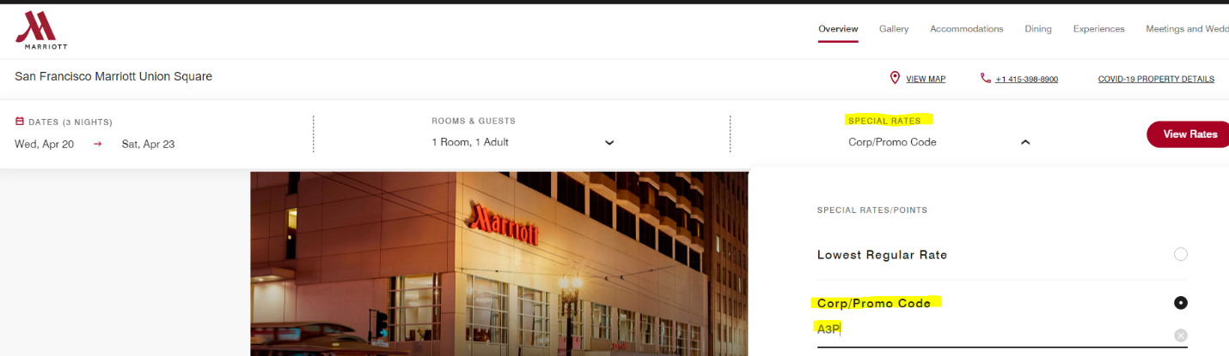

**Hyatt Regency San Francisco Airport**

[**1333 Bayshore Highway, Burlingame, CA 94010**](https://www.google.com/maps/search/?api=1&query=1333+Bayshore+Highway%2C+Burlingame%2C+California%2C+United+States%2C+94010)[**(650) 347- 1234**](tel:+1%20650%20347%201234)

[**Burlingame Hotels Near SFO | Hyatt Regency San Francisco Airport**](https://www.hyatt.com/en-US/hotel/california/hyatt-regency-san-francisco-airport/sfobu)

The hotel is at the crossroads of Burlingame, downtown San Francisco, Silicon Valley, and wine country. Stay here while awaiting a connection to an international flight, for San Francisco area explorations, or to celebrate a special occasion away.

|  |  |  |
| --- | --- | --- |
| Room Type | Single Occupancy Room Rate | Double Occupancy Room Rate |
| STANDARD KING/DDBL | $239.00 | 239.00 |
| Other Amenities: | Complimentary Guest Room WiFi; 24 Hour Airport Shuttle to/from SFO; Complimentary 24 Hour Fitness Center | |
| Check-in and Check-out Times: | Check in: 3PM Check Out: Noon | |

**Hotel Union Square**

**114 Powell Street  
San Francisco, CA 94102**

**Hotel Union Square** is a San Francisco Hotel that is situated in the heart of the [San Francisco Shopping District](http://hotelunionsquare.com/san-francisco-visitors-guide/shopping) with some of the finest department stores and designer shops around. The sounds of ringing cable car bells recall the nostalgic old San Francisco days. Built over 100 years ago in 1913 for the 1915 Pan Pacific Exposition, Union Square Hotel is a visually stimulating fusion of art deco and classic San Francisco style.

<https://hotelunionsquare.com/>